Database Setup – Demo App

By: Larry Ranches

Email: [rancheslp@outlook.com](mailto:rancheslp@outlook.com)

**Note: Screen Sheets are in Visual Studio 2013**

Setup Database using SQL Express (Localdb)\v11.0 connection

1. In your Server explorer View, right-click Data Connections. Select “Create New Sql Server Database” option.

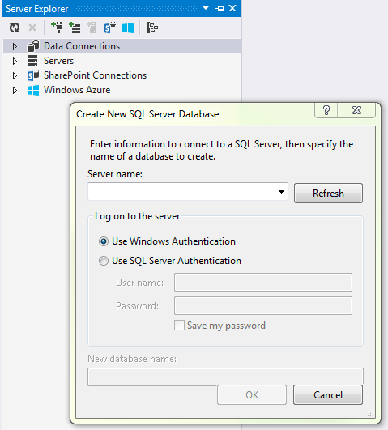

1. Enter in (localdb)\v11.0 as the server name and “DemoApp” as the database name. Select OK.

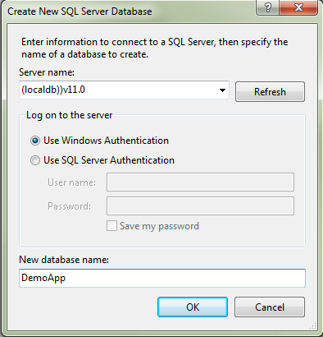

1. Under the newly created DemoApp Database, right-click “Tables” and select “New Query”.
2. Copy and paste UserTable.sql query into the query window. Execute the script.

